COOEE ABC:  HUMANS AREN’T CLOWNFISH  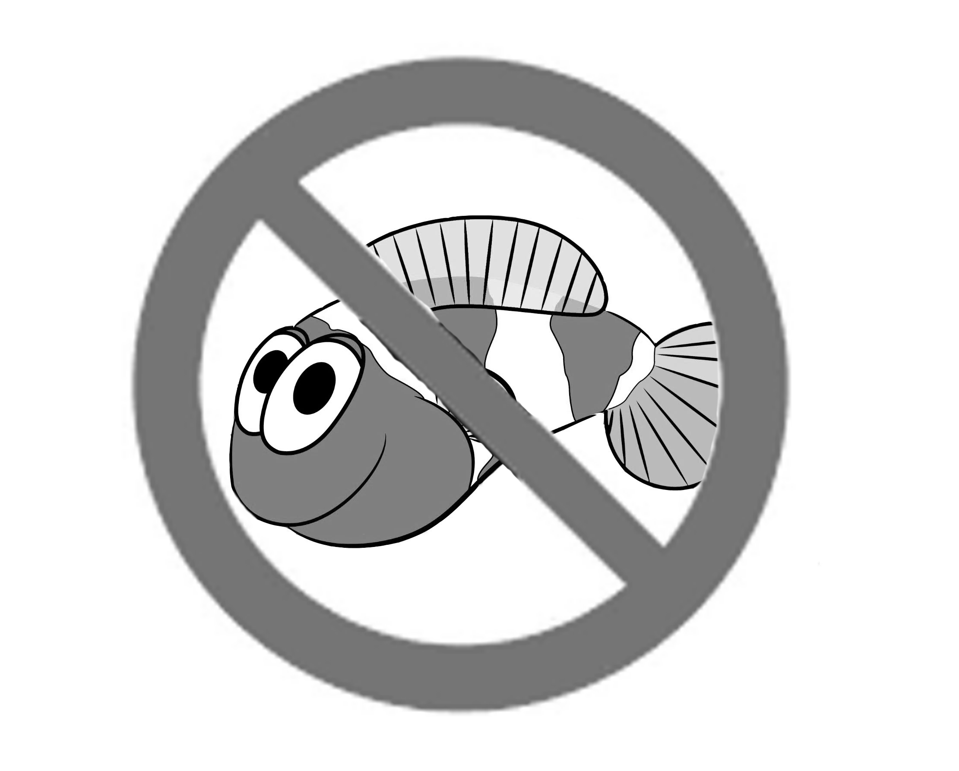  We don’t change sex | BREAK FREE OF TRANS LOBBY (ACON)

